SINGLE PRODUCT/SERVICE/BILLS PAGES
PRODUCTS
- Product Name
- Product Picture
- Product Code
- Product Details
- Product Categories
- Product Amount
- Sales/Discount %
- Colours of Product
- Sizes
- Quantity
- Offline/Online/Mobile
- Social Media Share Icons
- Business/Seller Information Section
- No of Sales
- Add to Chart Button
- Buy Now Button
- Shipping Info
- Warranty
- Return Policy
- Reviews
- Product Specification
- Star Rating
- Similar Products Section
- Contact Seller (Login)
- More items from Seller Section

SERVICE
- Service Name
- Service Picture/Flyer
- Service Code
- Service Details
- Service Categories
- Service Amount
- Sales/Discount %
- Quantity
- Social Media Share Icons
- Business/Seller Information Section
- No of Sales
- Add to Chart Button
- Buy Now Button
- Offline/Online/Mobile
- Warranty
- Return Policy
- Reviews
- Service Specification
- Star Rating
- Similar Service Section
- Contact Seller (Login)
- More items from Seller Section

SCREEN SHOT EXAMPLES FOR OTHER SERVICE/ BILLS/ EDUCATION/ CHURCH/ SALARY

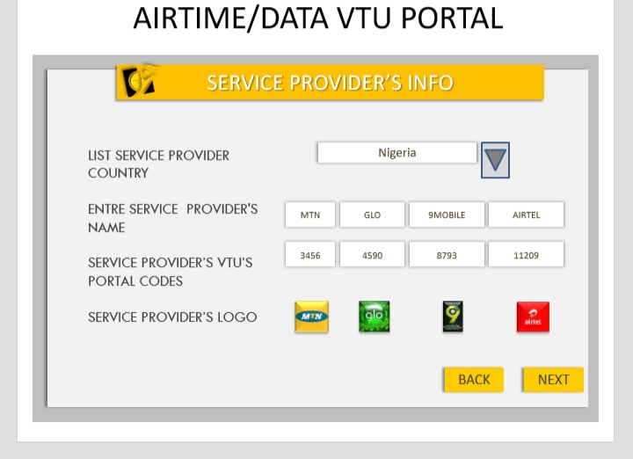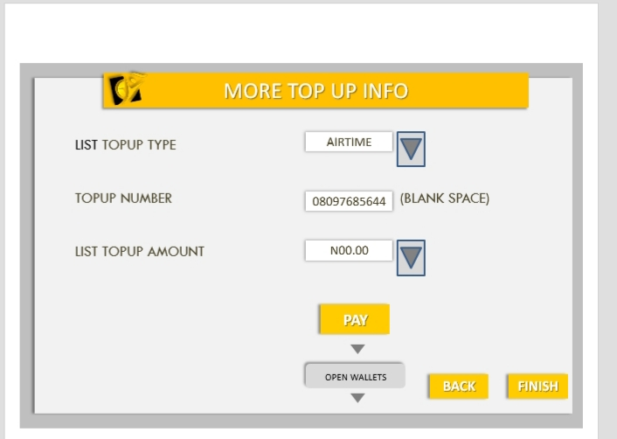
- If it’s a Church Section

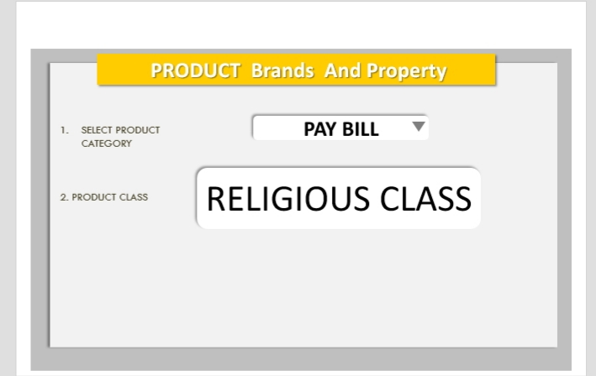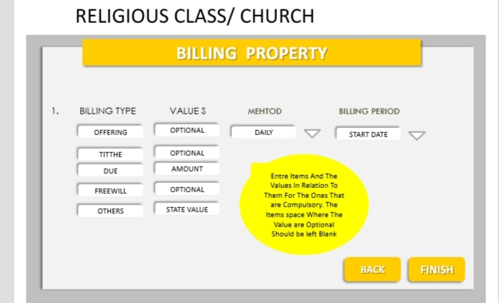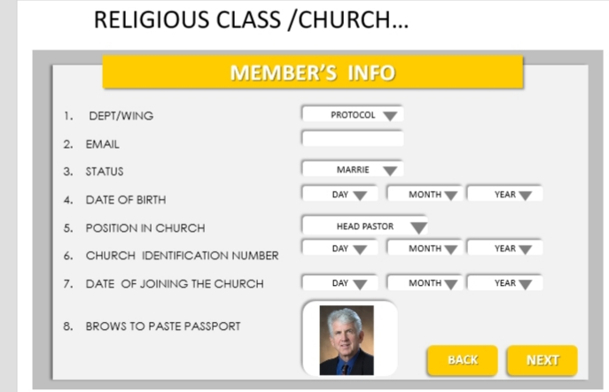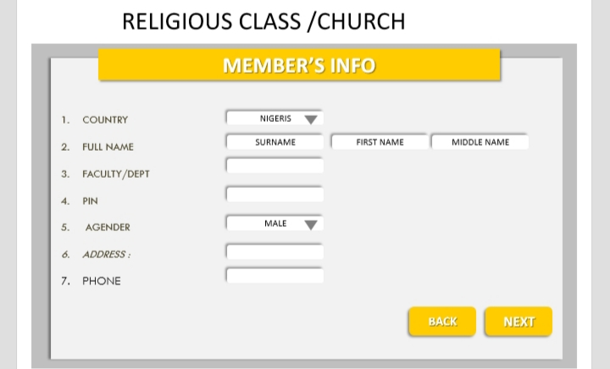

- If it’s a PAYROLL Section
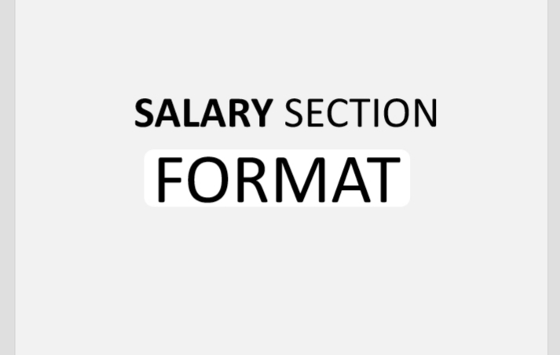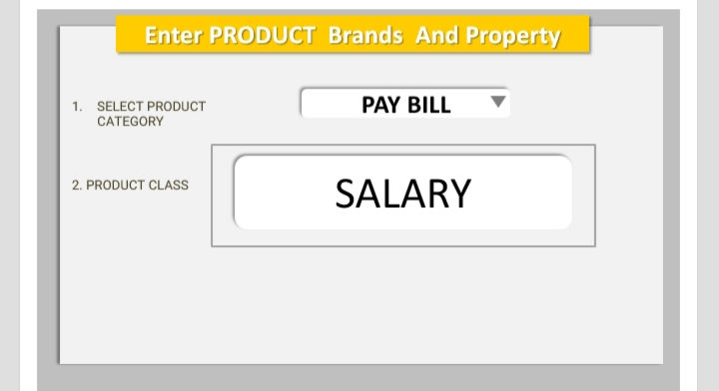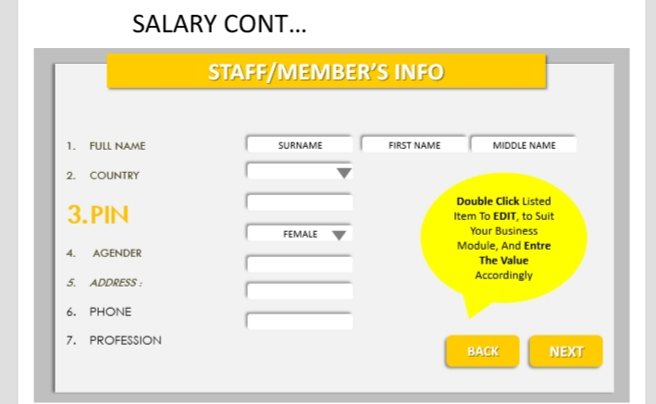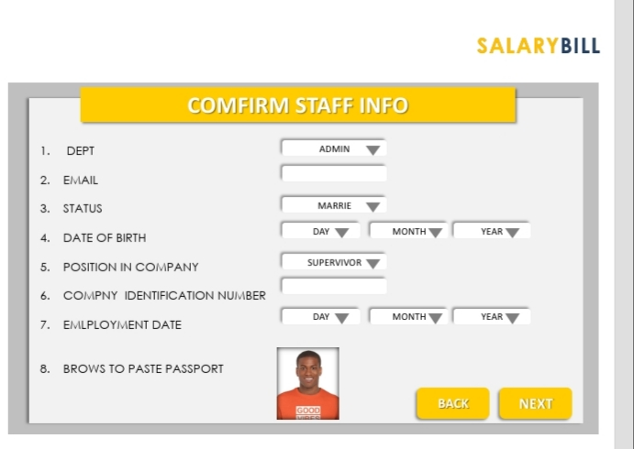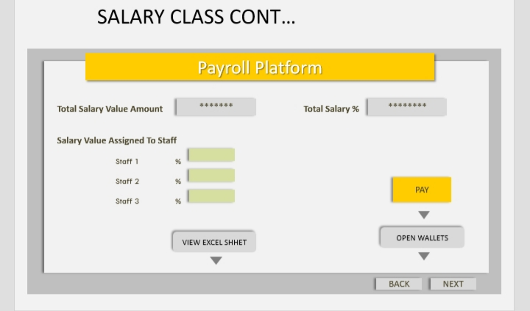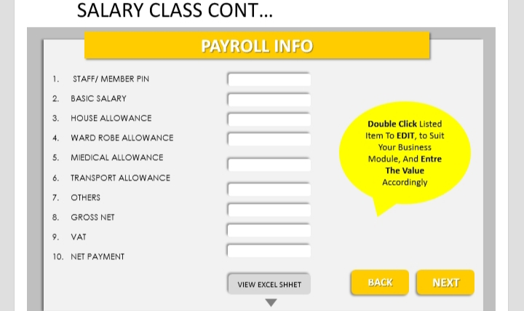
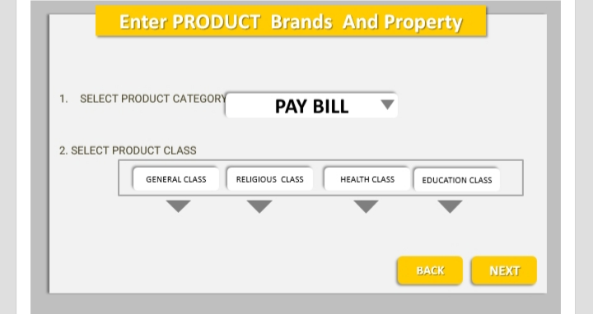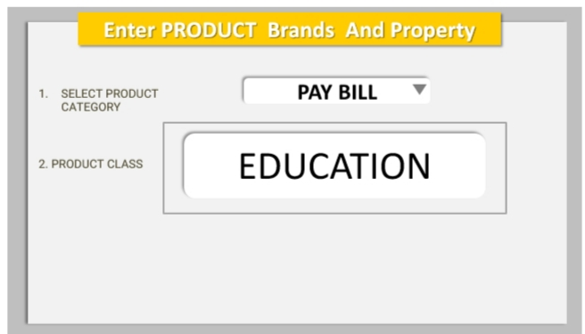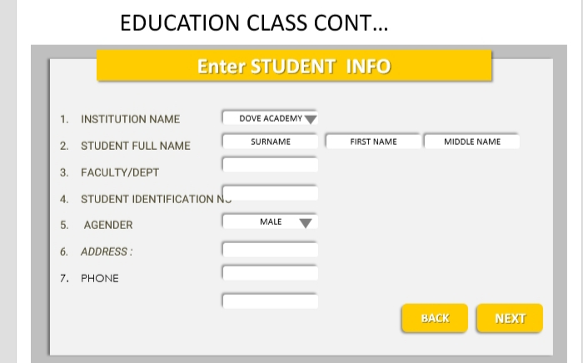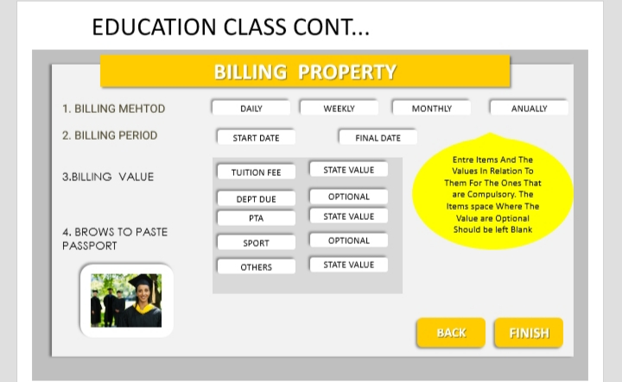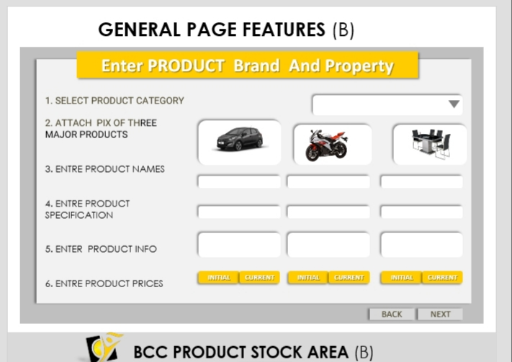

COMMUNITY FORUM
